Chapter 4, Solution 8.

Let V_{o} = V₁ + V₂, where V₁ and V₂ are due to 9-V and 3-V sources respectively. To find V₁, consider the circuit below.

+
_
3 Ω
9 V
V₁
9 Ω
1 Ω

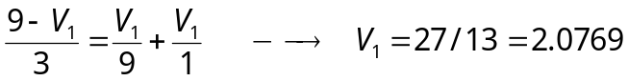

To find V₂, consider the circuit below.
3 Ω
3 V
9 Ω
V₁
+
_

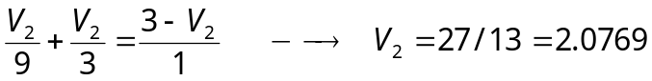

V_{o} = V₁ + V₂ = 4.1538 V

